React – HQL OUTPUTS

- Cricket App
Step – 1 : Create a react app named cricketapp.
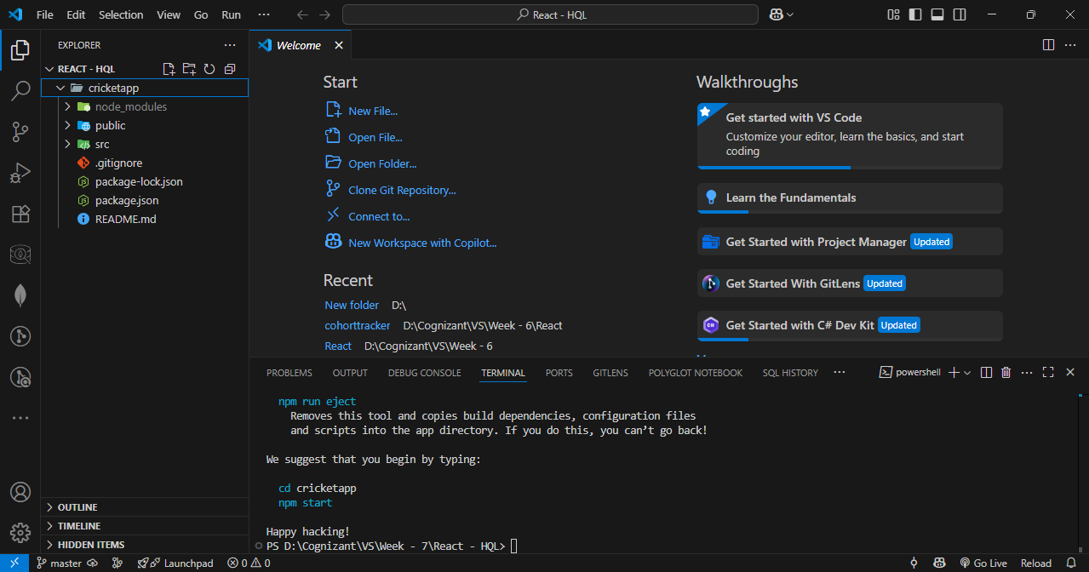

Step – 2 : Create a js file named ListofPlayers and enter details of players in it.
Code :
import React from 'react';
const players = [
{ name: 'Virat', score: 100 },
{ name: 'Rohit', score: 88 },
{ name: 'Rahul', score: 67 },
{ name: 'Jadeja', score: 71 },
{ name: 'Pant', score: 62 },
{ name: 'Ashwin', score: 56 },
{ name: 'Hardik', score: 74 },
{ name: 'Bumrah', score: 45 },
{ name: 'Gill', score: 85 },
{ name: 'Shreyas', score: 59 },
{ name: 'Kuldeep', score: 68 },
];
const players70 = players.filter((item) => item.score <= 70);
const ListofPlayers = () => {
return (
<div>
<h2>All Players</h2>
<ul>
{players.map((item, index) => (
<li key={index}>
Mr. {item.name} <span>({item.score})</span>
</li>
))}
</ul>
<h2>Players with Score ≤ 70</h2>
<ul>
{players70.map((item, index) => (
<li key={index}>{item.name} - {item.score}</li>
))}
</ul>
</div>
);
};
export default ListofPlayers;
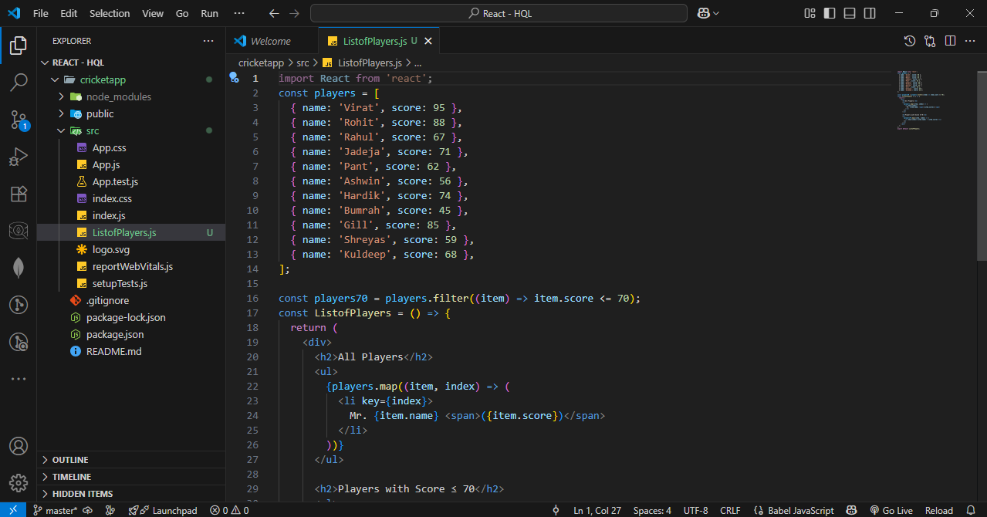

Step – 3 : Create two js files named oddplayer.js and evenplayer.js. Display them using the Destructuring features of ES6.
OddPlayers.js
Code :
import React from 'react';

export function OddPlayers({ players }) {
const oddPlayers = players.filter((_, index) => index % 2 === 0); // 0,2,4,...

return (
<div>
<h3>Odd Team Players (1st, 3rd...)</h3>
<ul>
{oddPlayers.map((player, index) => (
<li key={index}>{player}</li>
))}
</ul>
</div>
);
}
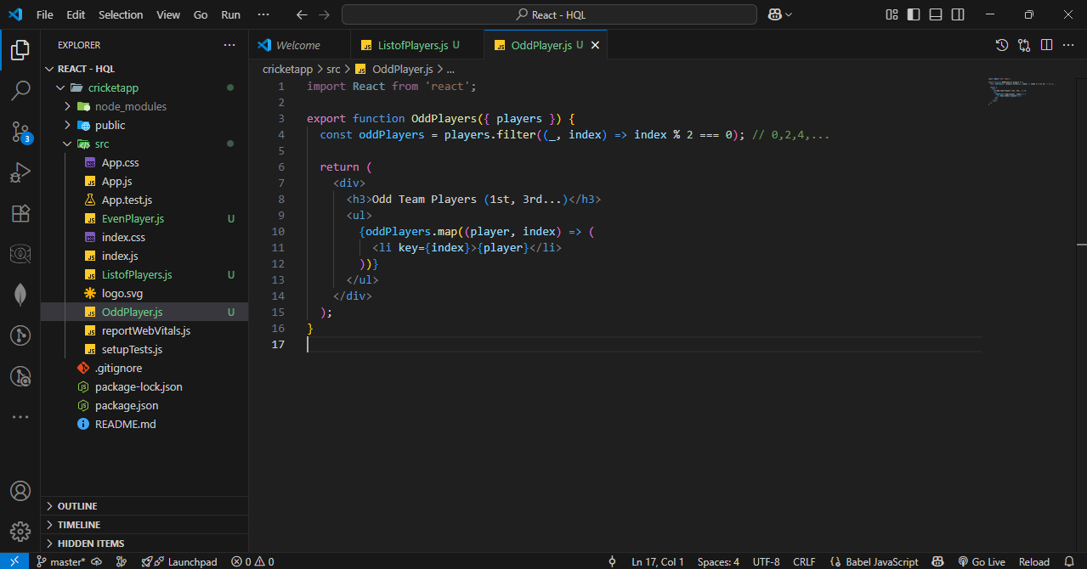

EvenPlayer.js Code :
import React from 'react';

export function EvenPlayers({ players }) {
const evenPlayers = players.filter((_, index) => index % 2 !== 0); // 1,3,5,...

return (
<div>
<h3>Even Team Players (2nd, 4th...)</h3>
<ul>
{evenPlayers.map((player, index) => (
<li key={index}>{player}</li>
))}
</ul>
</div>
);
}
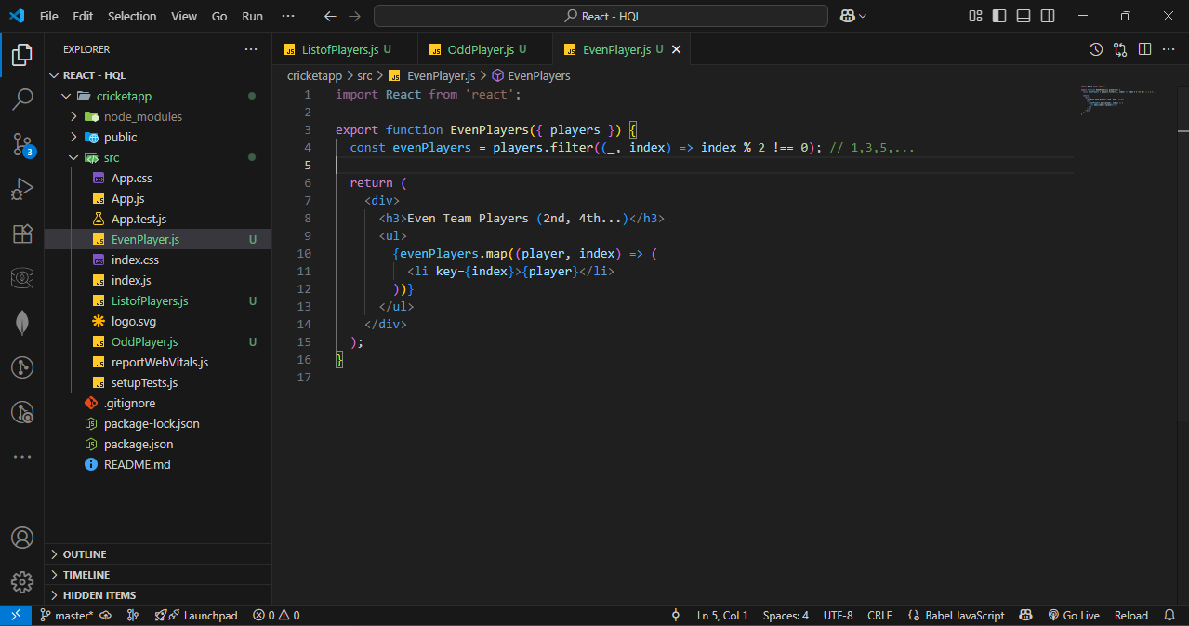

Step – 4 : Create a js file named IndianPlayer.js and Declare two arrays T20players and RanjiTrophy players and merge the two arrays and display them using the Merge feature of ES6.
Code :
import React from 'react';
import { OddPlayers } from './OddPlayers';
import { EvenPlayers } from './EvenPlayers';

const T20Players = ['First Player', 'Second Player', 'Third Player'];
const RanjiTrophyPlayers = ['Fourth Player', 'Fifth Player', 'Sixth Player', 'Seventh Player', 'Eighth Player', 'Ninth Player', 'Tenth Player', 'Eleventh Player'];

const allPlayers = [...T20Players, ...RanjiTrophyPlayers];

export const IndianPlayers = () => {
return (
<div>
<h2>All Indian Players</h2>
<ul>
{allPlayers.map((player, index) => (
<li key={index}>{player}</li>
))}
</ul>

<OddPlayers players={allPlayers} />
<EvenPlayers players={allPlayers} />
</div>
);
};
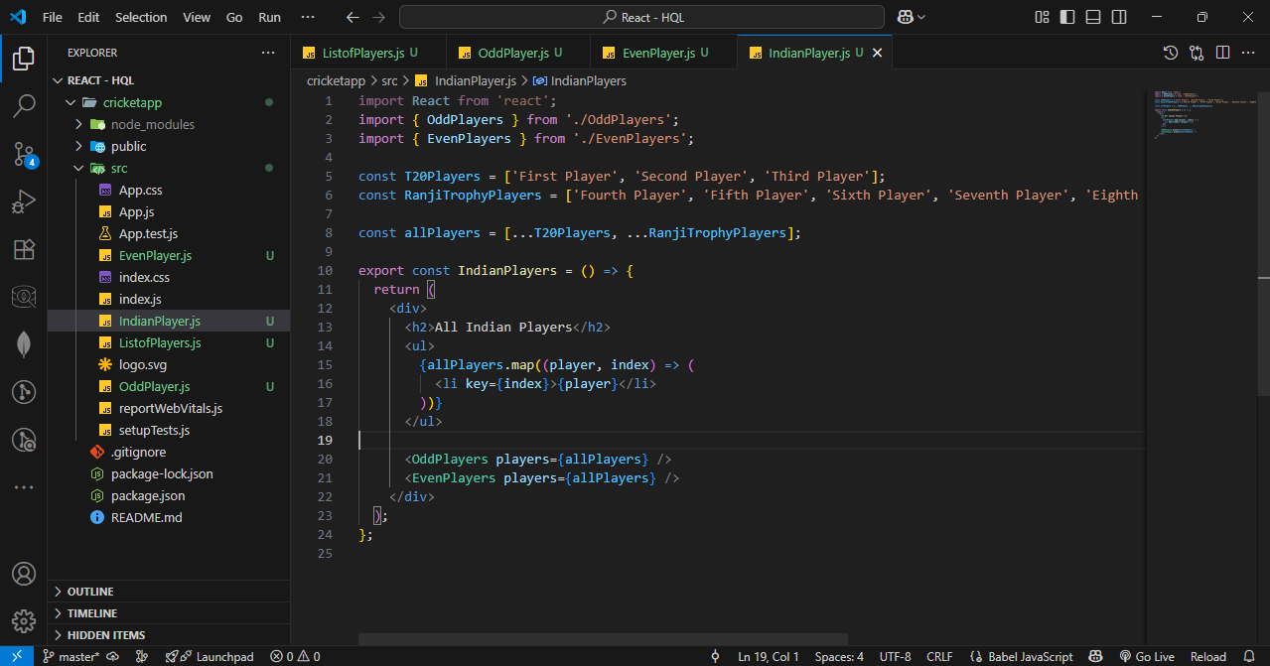

Step – 5 : Update App.js.
Code :
import React from 'react';
import ListofPlayers from './ListofPlayers';
import { IndianPlayers } from './IndianPlayers';
function App() {
const flag = true;
return (
<div className="App">
<h1>Cricket App</h1>
{flag ? <ListofPlayers /> : <IndianPlayers />}
</div>
);
}
export default App;
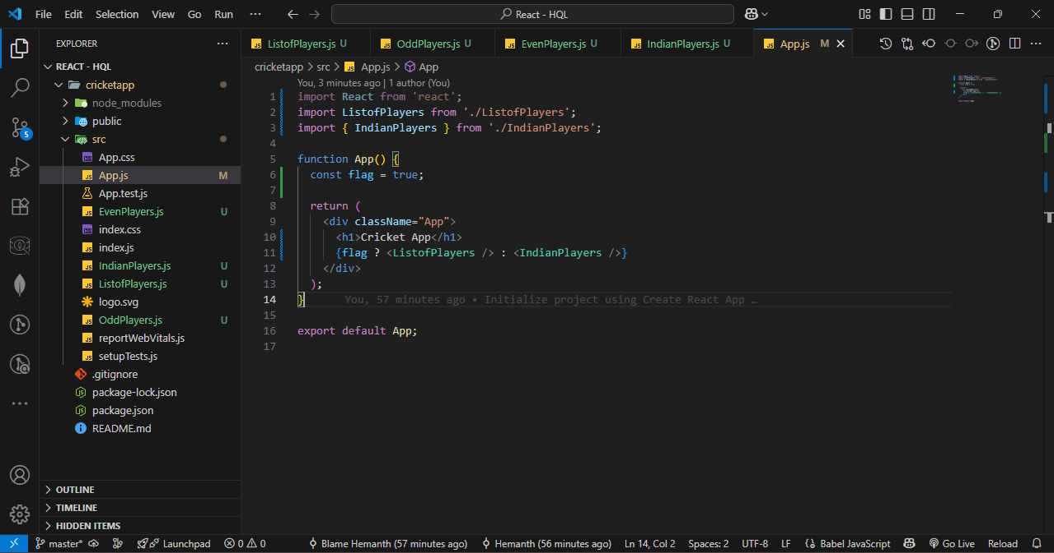

Step – 6 : Start the server.
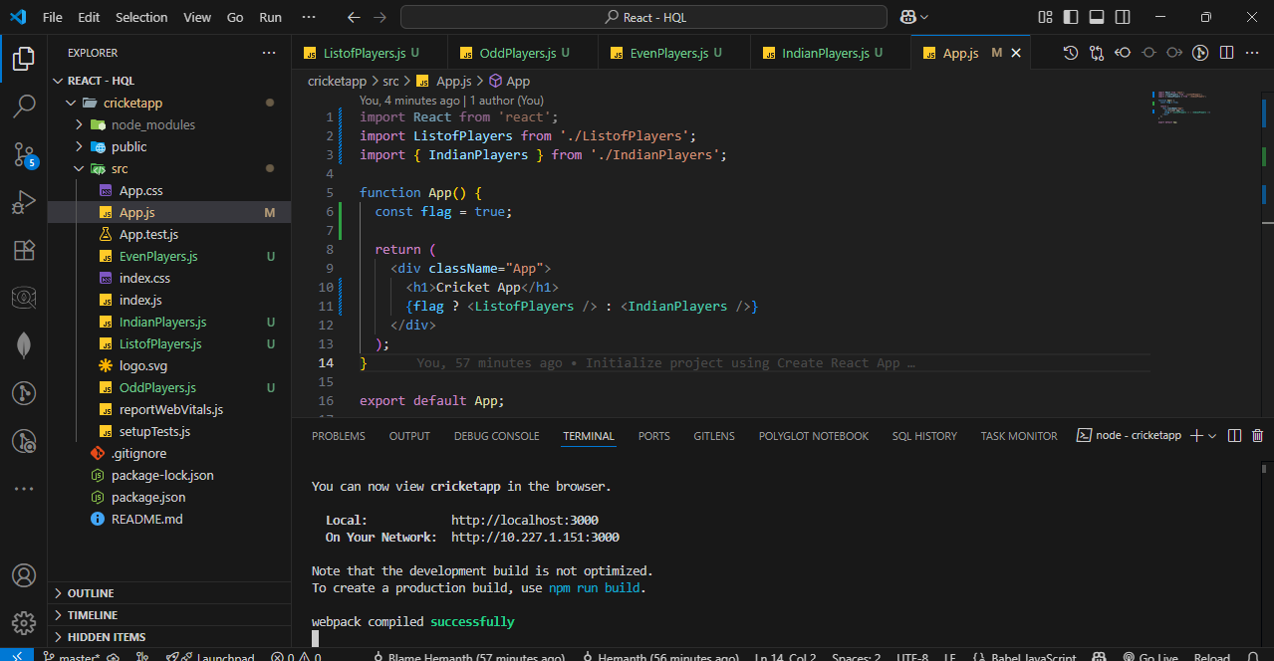

OUTPUT :
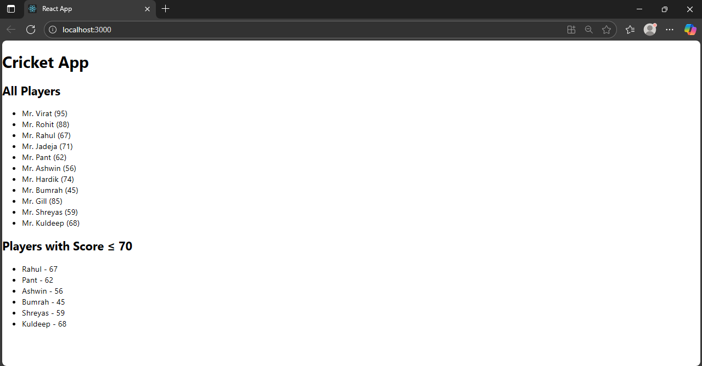

- Office Space Rental App
Step – 1 : Create a react app named officespacerentalapp.
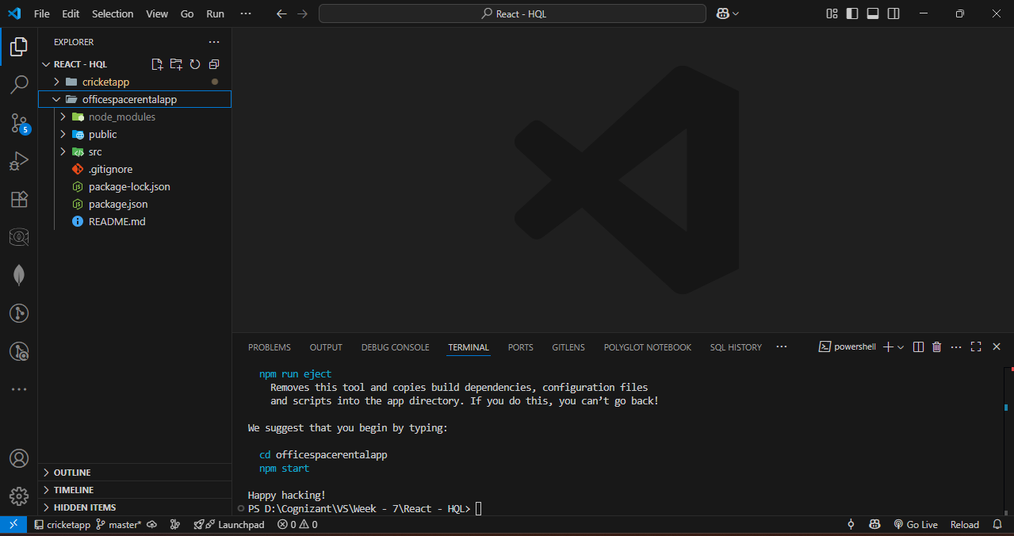

Step – 2 : update App.js and App.css
App.js Code :
import React from 'react';
import sr from './office.jpeg';
import './App.css';

function App() {
const ItemName = { Name: "DBS", Rent: 50000, Address: "Chennai" };

const rentColorClass = ItemName.Rent <= 60000 ? 'textRed' : 'textGreen';

const element = "Office Space";
const jsxatt = <img src={sr} width="25%" height="25%" alt="Office Space" />;

return (
<div
style={{
display: 'flex',
flexDirection: 'column',
alignItems: 'center',
justifyContent: 'center',
minHeight: '100vh',
textAlign: 'center',
}}
>
<h1>{element}, at Affordable Range</h1>
{jsxatt}
<h1>Name: {ItemName.Name}</h1>
<h3 className={rentColorClass}>Rent: ₹{ItemName.Rent}</h3>
<h3>Address: {ItemName.Address}</h3>
</div>
);
}

export default App;
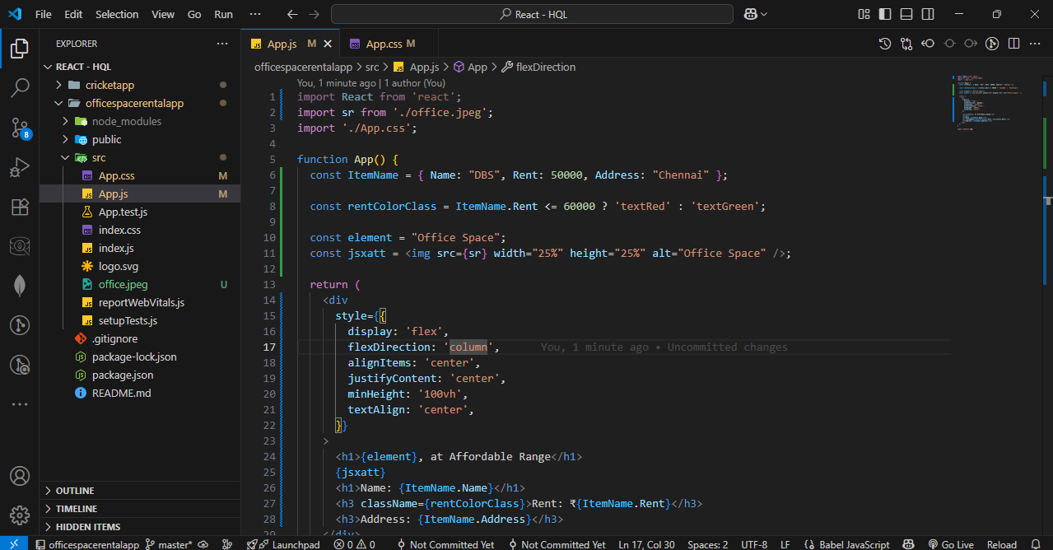
App.css Code :
.textRed {
color: red;
}

.textGreen {
color: green;
}
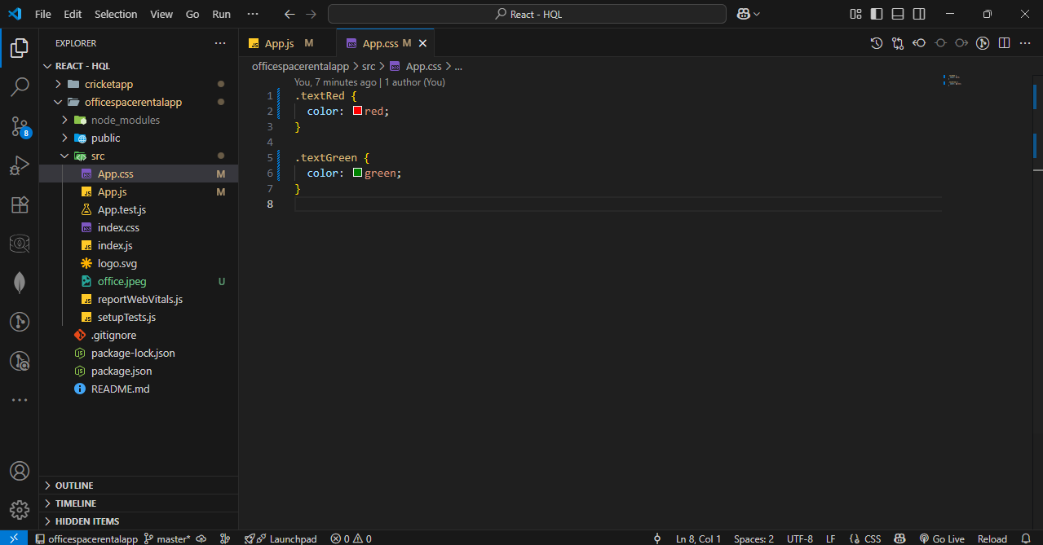

Step – 3 : Start the server.
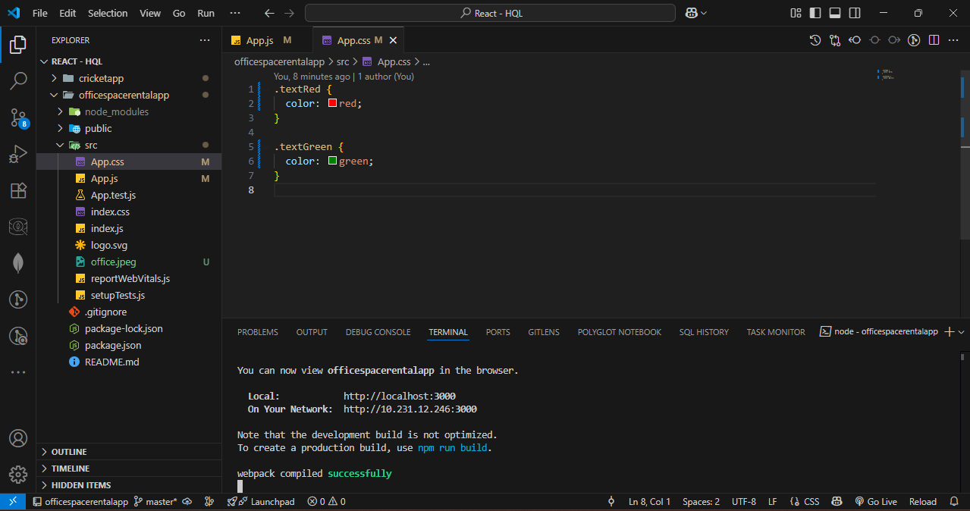

OUTPUT :
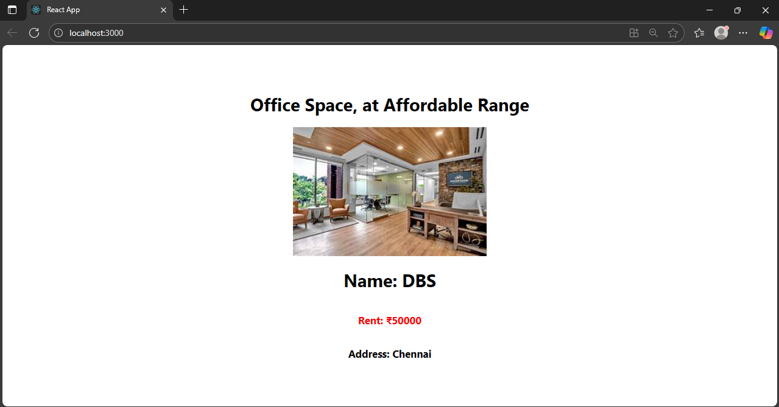

- Event Example App
Step – 1 : Create a react app named eventexamplesapp.
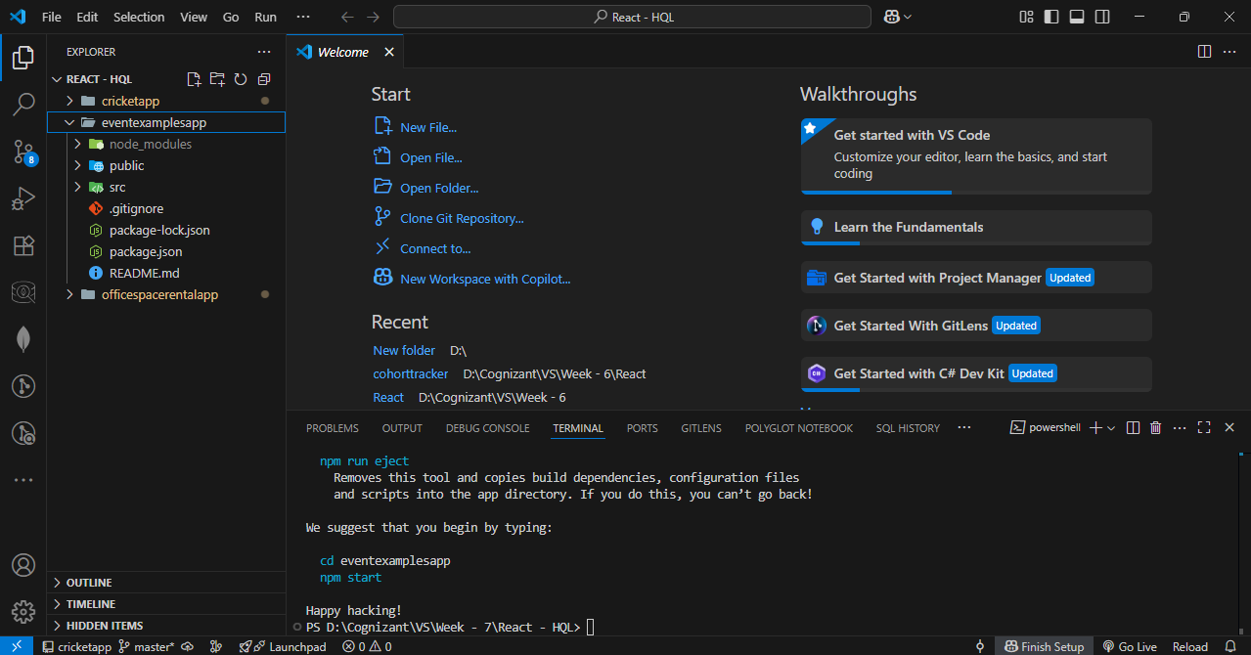

Step – 2 : Update app.js and app.css as per given instructions.
App.js Code :
import React, { useState } from 'react';
import './App.css';

function App() {
const [count, setCount] = useState(5);
const [amount, setAmount] = useState('');
const [currency, setCurrency] = useState('');

const sayWelcome = () => {
alert("welcome");
};

const handleSubmit = (e) => {
e.preventDefault();
alert(`Converting ${amount} to ${currency}`);
};

return (
<div className="app-container">
<div className="counter">{count}</div>

<div className="button-group">
<button onClick={() => setCount(count + 1)}>Increment</button>
<button onClick={() => setCount(count - 1)}>Decrement</button>
<button onClick={sayWelcome}>Say welcome</button>
<button onClick={() => alert('Clicked!')}>Click on me</button>
</div>

<h1 className="title">Currency Convertor!!!</h1>

<form onSubmit={handleSubmit} className="currency-form">
<div className="form-row">
<label>Amount:</label>
<input
type="text"
value={amount}
onChange={(e) => setAmount(e.target.value)}
/>
</div>

<div className="form-row">
<label>Currency:</label>
<textarea
value={currency}
onChange={(e) => setCurrency(e.target.value)}
/>
</div>

<button type="submit">Submit</button>
</form>
</div>
);
}
export default App;
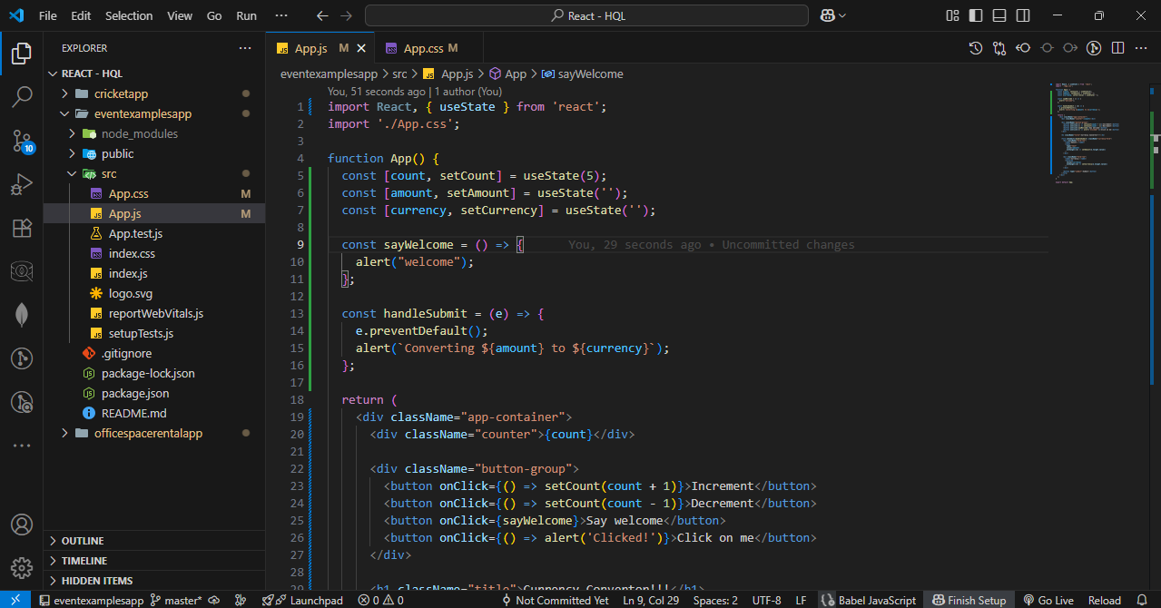
App.css Code :
.app-container {
padding: 20px;
font-family: Arial, sans-serif;
}
.counter {
font-size: 20px;
margin-bottom: 10px;
}
.button-group {
display: flex;
flex-direction: column;
gap: 5px;
max-width: 150px;
margin-bottom: 30px;
}
.button-group button {
padding: 5px;
}
.title {
color: green;
font-weight: bold;
font-size: 28px;
margin-bottom: 20px;
}
.currency-form {
display: flex;
flex-direction: column;
gap: 15px;
max-width: 300px;
}
.form-row {
display: flex;
align-items: center;
gap: 10px;
}
label {
width: 80px;
}
input, textarea {
width: 150px;
}
button[type="submit"] {
width: 100px;
padding: 5px;
}

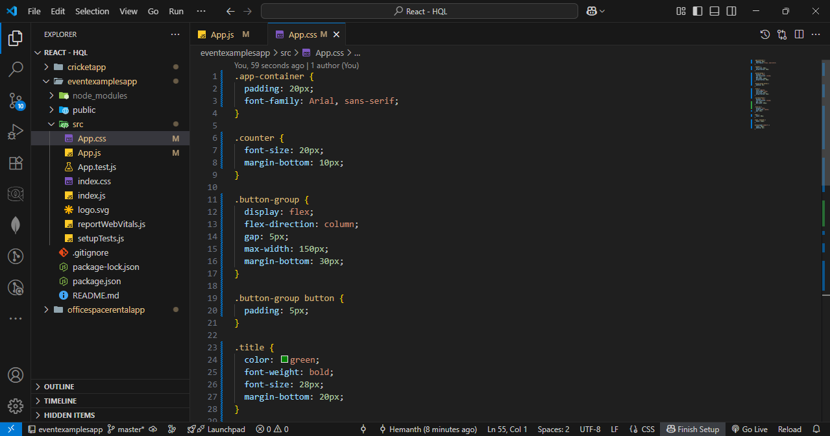

Step – 3 : Start the server.
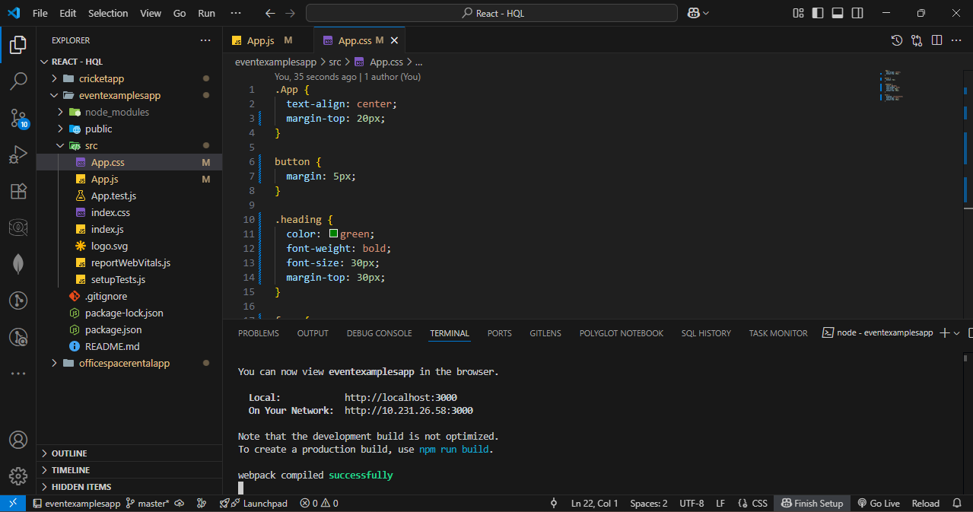

OUTPUT :
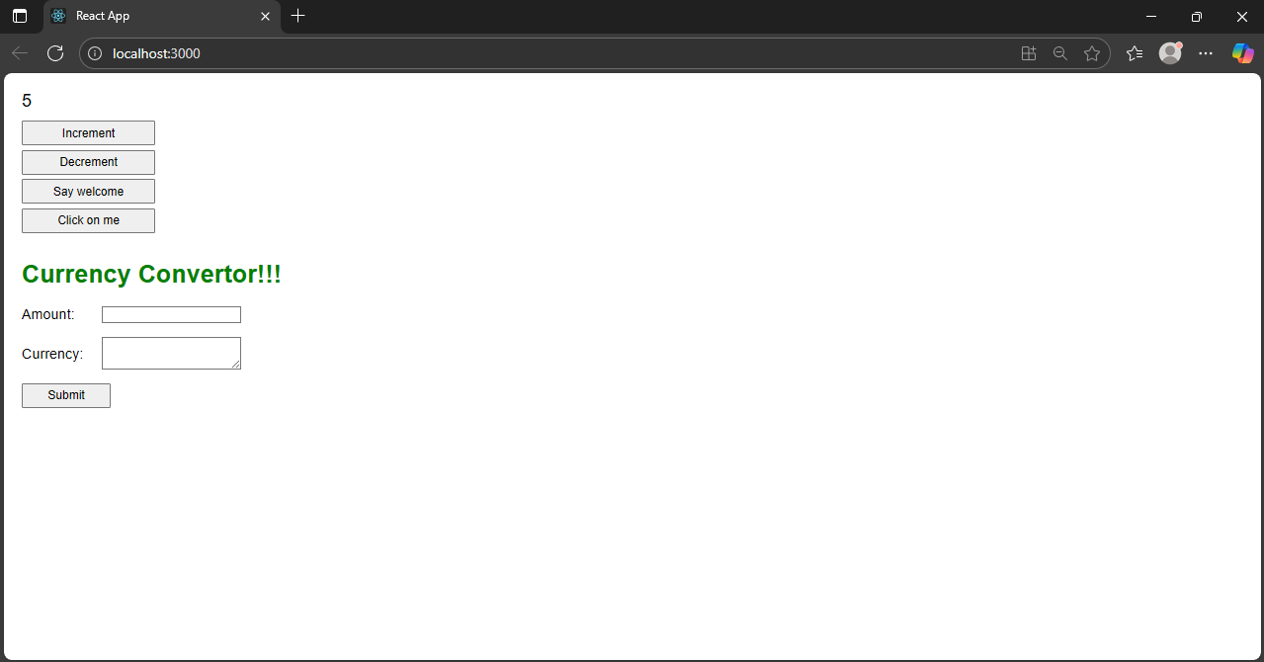
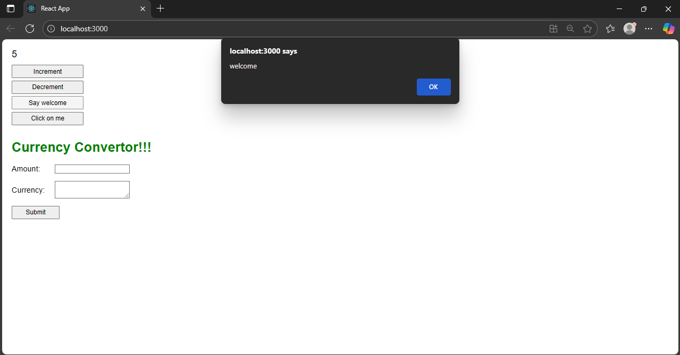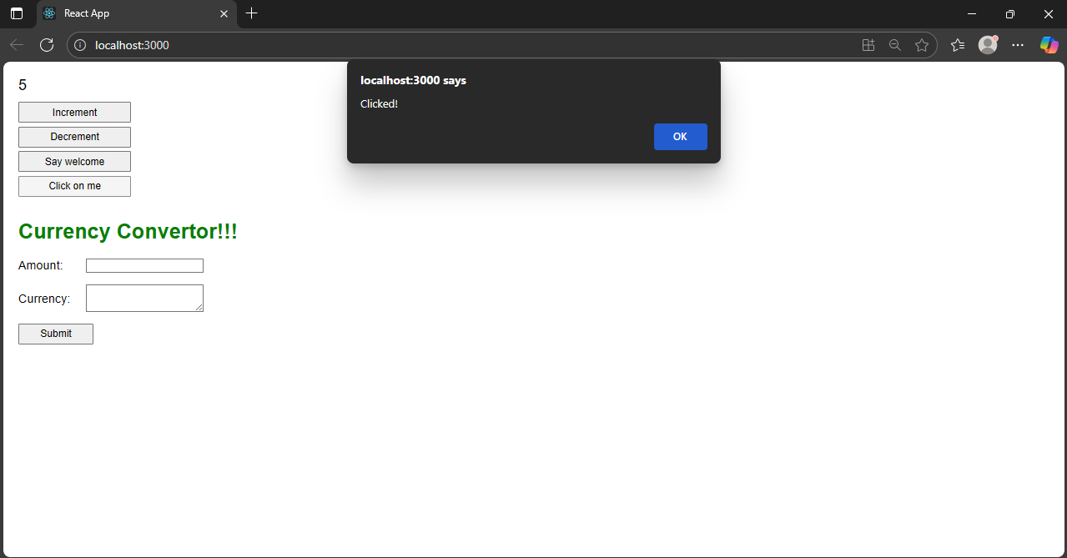
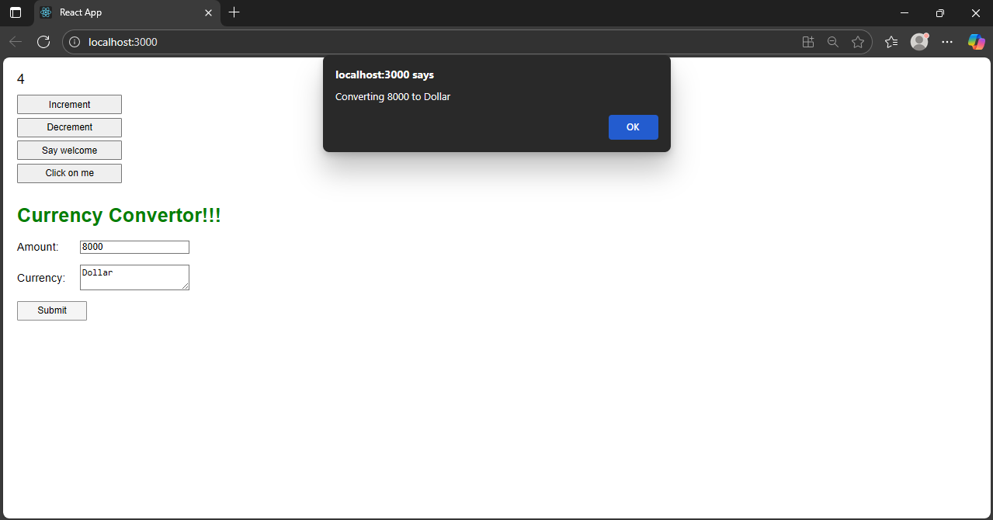

- Login greating App.
Step – 1 : Create a react app named login-greating-app.
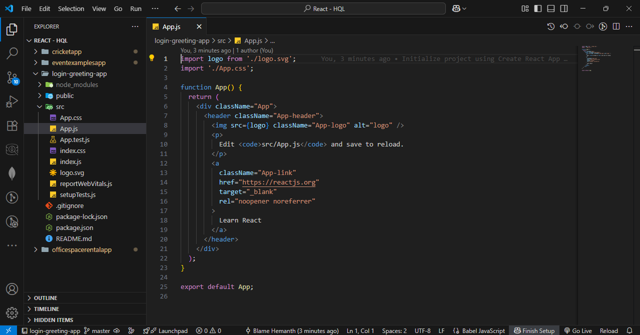

Step – 2 : Update the code of app.js and app.css as per instructions.
App.js Code :
import React, { useState } from 'react';
import './App.css';

function LoginButton({ onClick }) {
return <button className="btn" onClick={onClick}>Login</button>;
}

function LogoutButton({ onClick }) {
return <button className="btn" onClick={onClick}>Logout</button>;
}

function UserGreeting() {
return <h1 className="black-text">Welcome back</h1>;
}

function GuestGreeting() {
return <h1 className="black-text">Please sign up.</h1>;
}

function Greeting({ isLoggedIn }) {
return isLoggedIn ? <UserGreeting /> : <GuestGreeting />;
}
function App() {
const [isLoggedIn, setIsLoggedIn] = useState(false);

return (
<div className="container">
<Greeting isLoggedIn={isLoggedIn} />
{isLoggedIn ? (
<LogoutButton onClick={() => setIsLoggedIn(false)} />
) : (
<LoginButton onClick={() => setIsLoggedIn(true)} />
)}
</div>
);
}
export default App;
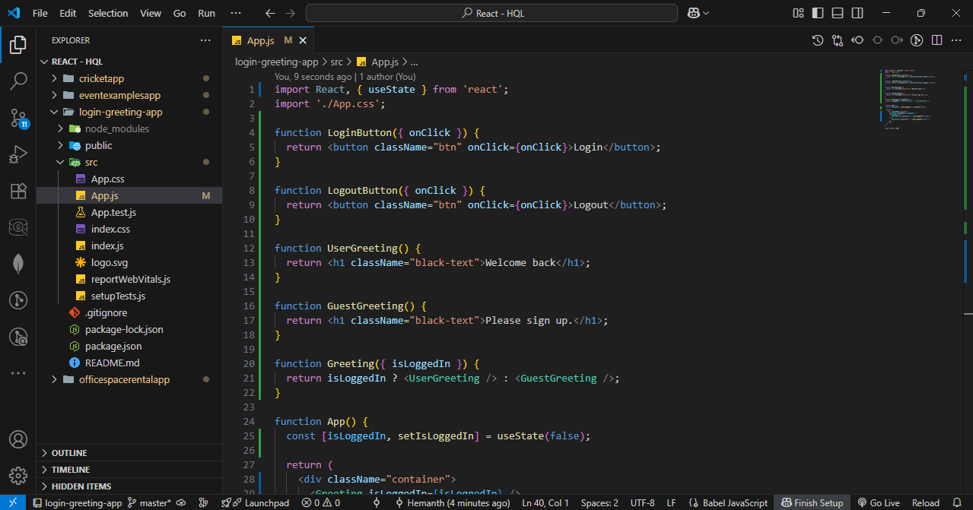
App.css Code :
.container {
text-align: center;
margin-top: 20%;
font-family: 'Arial', sans-serif;
}

.black-text {
color: black;
margin-bottom: 20px;
}

.btn {
padding: 10px 20px;
font-size: 16px;
cursor: pointer;
}
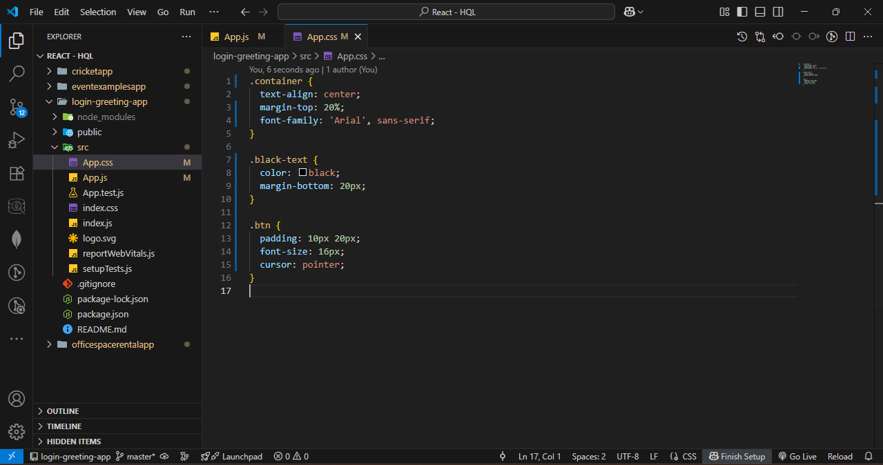

Step – 3 : Start the server.
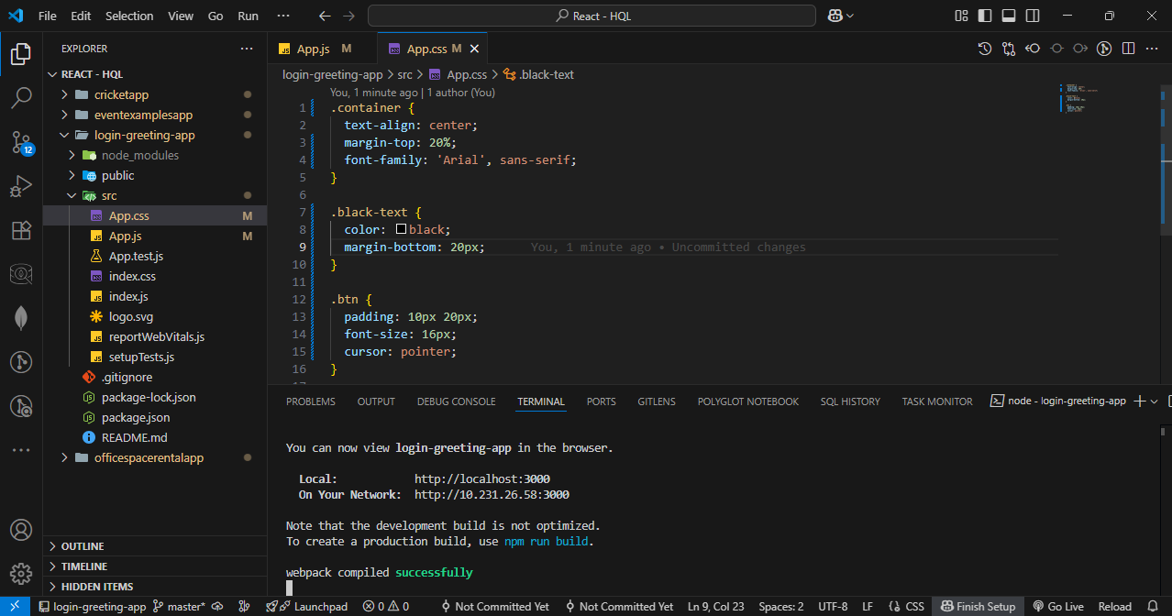

OUTPUT :
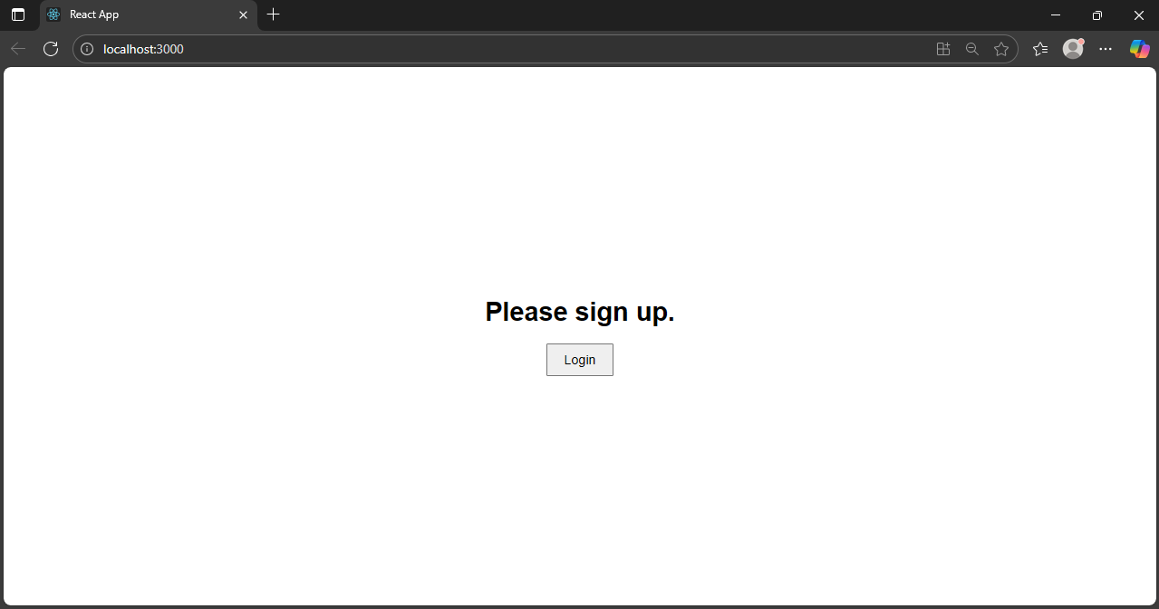
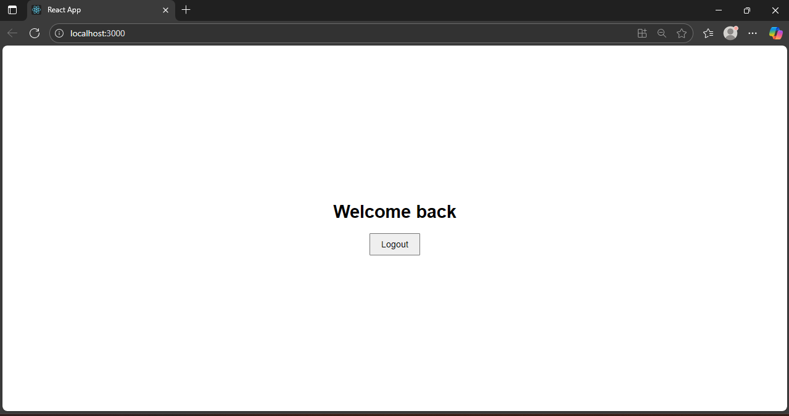

- Blogger App
Step – 1 : Create a react app named bloggerapp.
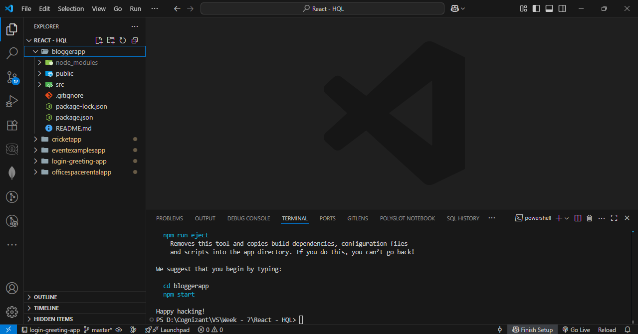

Step – 2 : Create two folders named components and data in src folder.
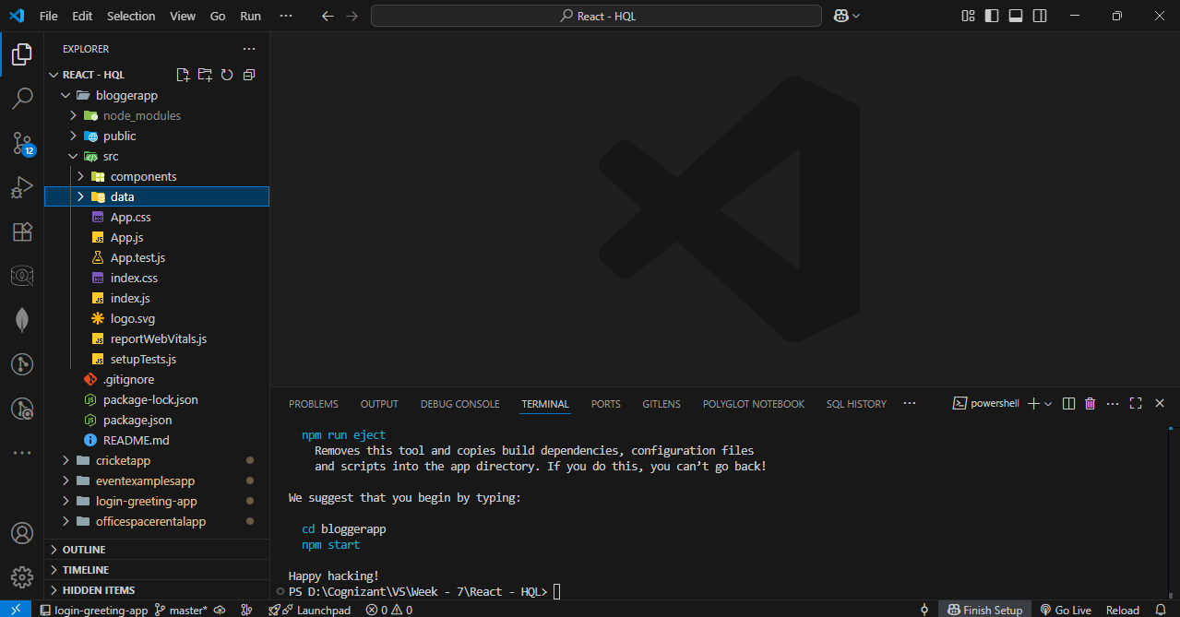
Step – 3 : Create three files named BookDetails.js, BlogDetails.js, and CourseDetails.js in components folder.
BookDetails.js Code :
import React from 'react';

const BookDetails = ({ books }) => {
return (
<ul>
{books.map((book) => (
<div key={book.id}>
<h3>{book.bname}</h3>
<h4>{book.price}</h4>
</div>
))}
</ul>
);
};

export default BookDetails;
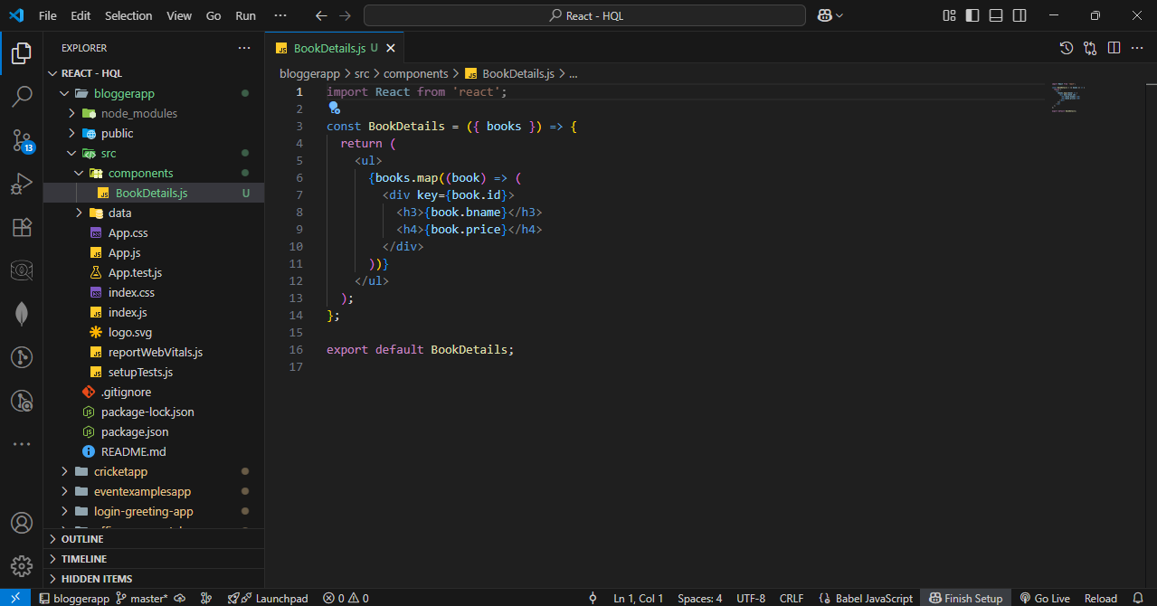
BlogDetails.js Code :
import React from 'react';

const BlogDetails = () => {
return (
<div>
<h2>React Learning</h2>
<h4>Stephen Biz</h4>
<p>Welcome to learning React!</p>

<h2>Installation</h2>
<h4>Schwezdenier</h4>
<p>You can install React from npm.</p>
</div>
);
};

export default BlogDetails;
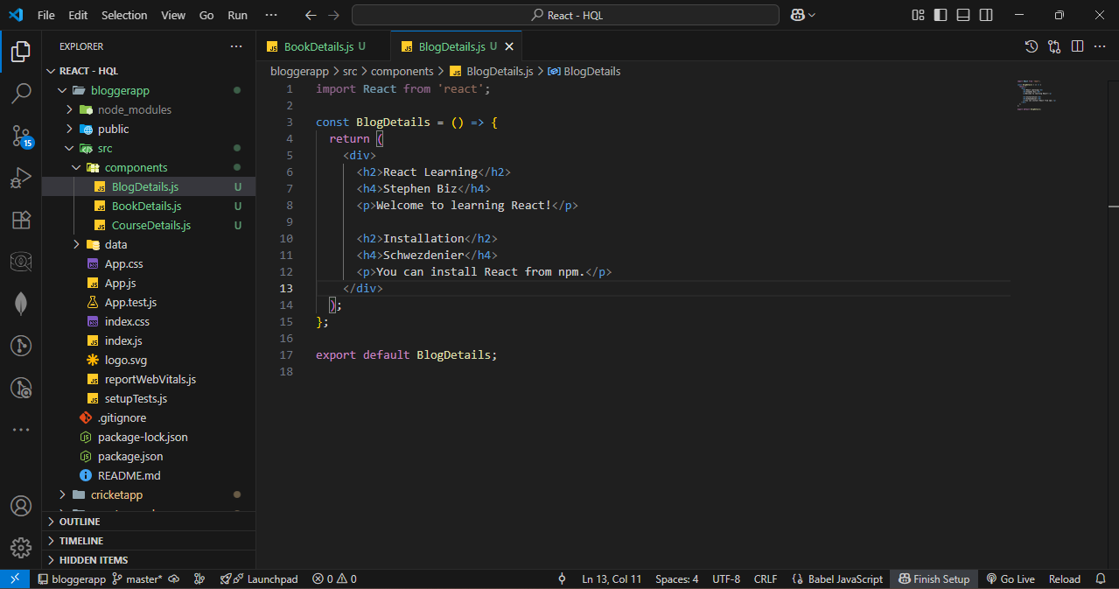
CourseDetails.js Code :
import React from 'react';

const CourseDetails = () => {
return (
<div>
<h2>Angular</h2>
<p>4/5/2021</p>

<h2>React</h2>
<p>6/3/20201</p> {/* Note: likely a typo in year */}
</div>
);
};

export default CourseDetails;
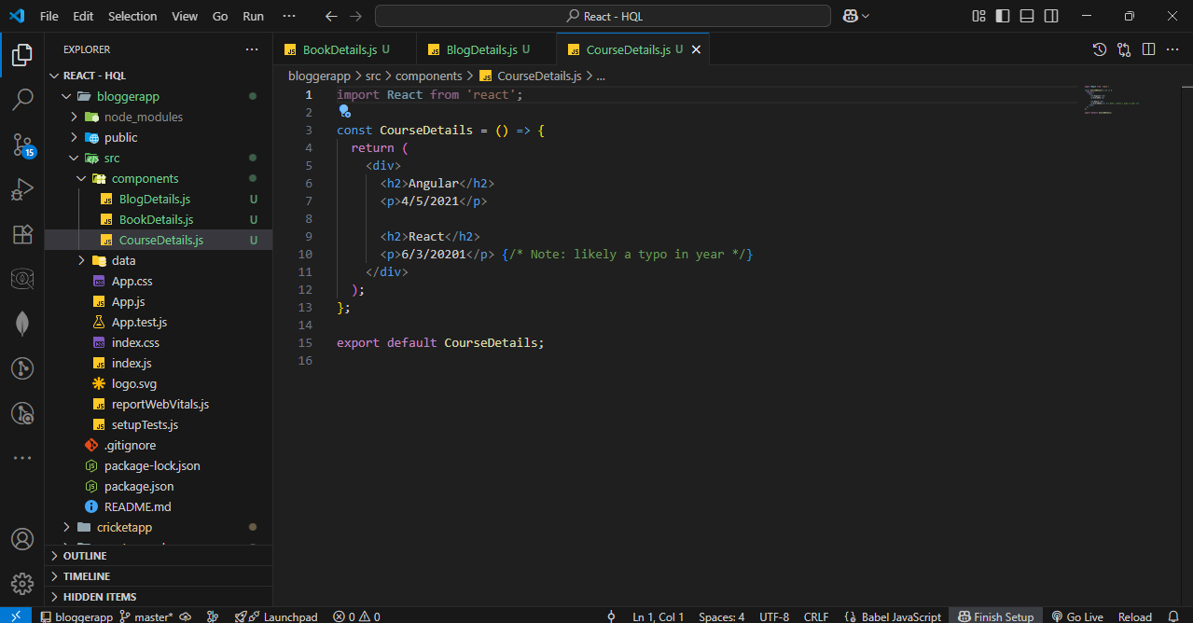

Step – 4 : Create three files named Books.js, Blogs.js, and Courses.js in data folder.
Books.js Code :
export const books = [
{ id: 101, bname: 'Master React', price: 670 },
{ id: 102, bname: 'Deep Dive into Angular 11', price: 800 },
{ id: 103, bname: 'Mongo Essentials', price: 450 },
];
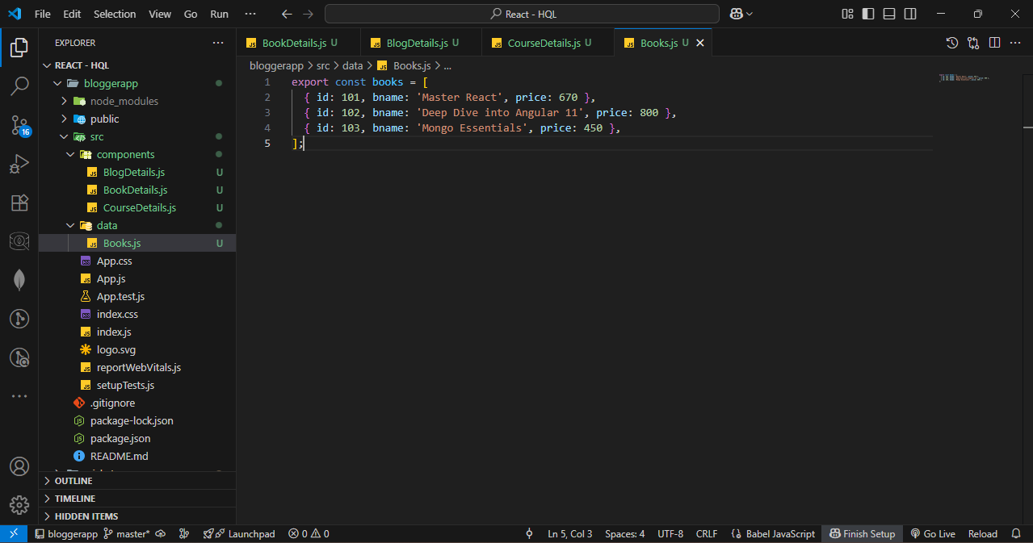
Blogs.js Code :
export const blogs = [
{
id: 201,
title: 'React Learning',
author: 'Stephen Biz',
description: 'Welcome to learning React!',
},
{
id: 202,
title: 'Installation',
author: 'Schwezdenier',
description: 'You can install React from npm.',
},
];

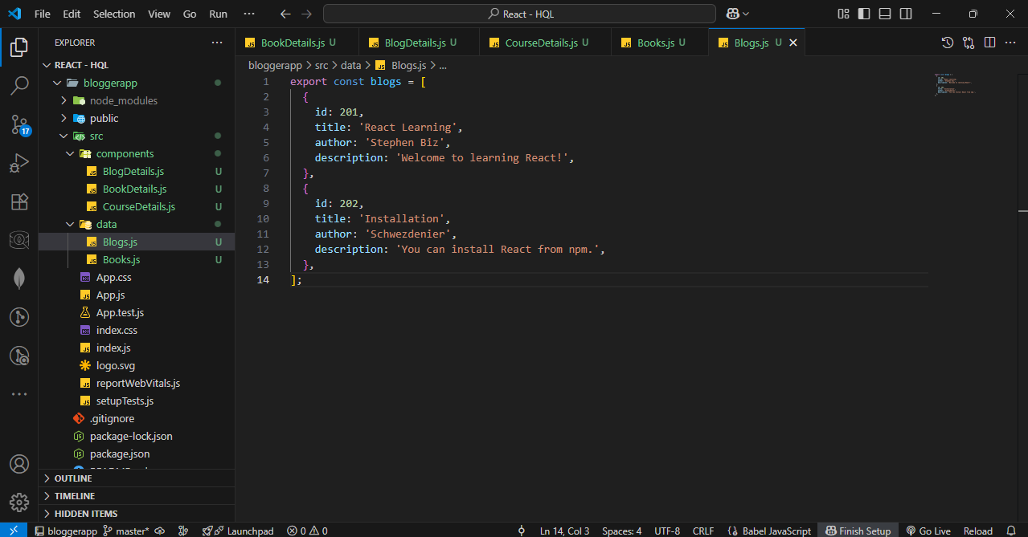
Courses.js Code :
// src/data/courses.js

export const courses = [
{
id: 301,
name: 'Angular',
date: '4/5/2021',
},
{
id: 302,
name: 'React',
date: '6/3/2021',
},
];
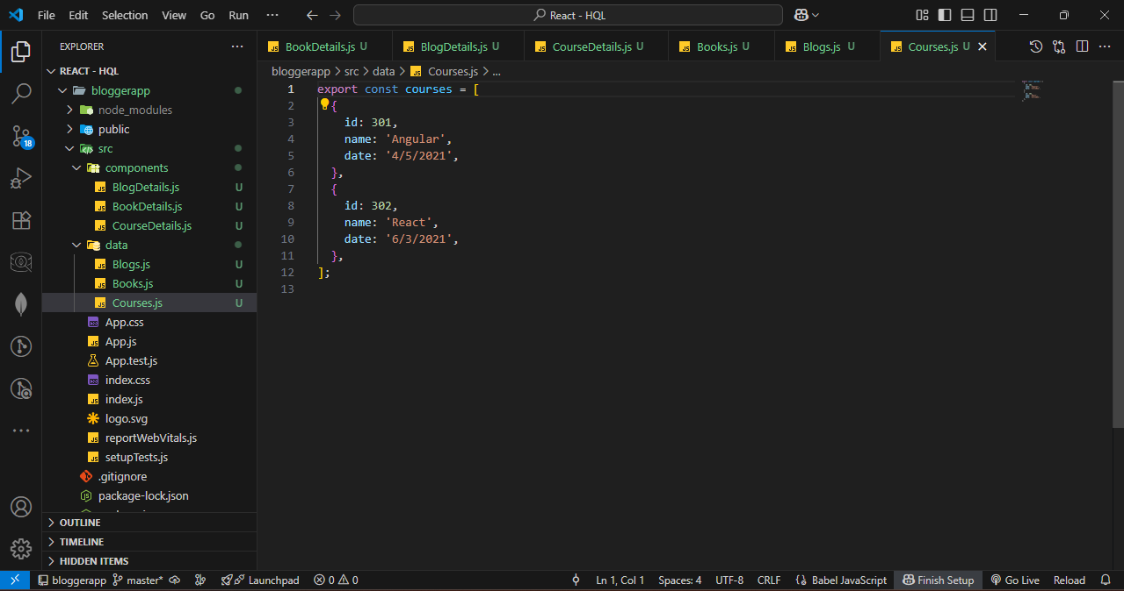

Step – 5 : Update app.js.
App.js Code :
import React, { useState } from 'react';
import './App.css';

// Import data
import { books } from './data/Books';
import { blogs } from './data/Blogs';
import { courses } from './data/Courses';

// Import components
import BookDetails from './components/BookDetails';
import BlogDetails from './components/BlogDetails';
import CourseDetails from './components/CourseDetails';

function App() {
const [showBooks, setShowBooks] = useState(true);
const [showBlogs, setShowBlogs] = useState(true);
const [showCourses, setShowCourses] = useState(true);

return (
<div className="container" style={{ display: 'flex', justifyContent: 'space-around', padding: '20px' }}>

{/* Course Details */}
{showCourses && (
<div className="mystyle1" style={{ borderLeft: '5px solid green', paddingLeft: '20px' }}>
<h1>Course Details</h1>
<CourseDetails courses={courses} />
</div>
)}

{/* Book Details */}
{showBooks && (
<div className="st2" style={{ borderLeft: '5px solid green', paddingLeft: '20px' }}>
<h1>Book Details</h1>
<BookDetails books={books} />
</div>
)}

{/* Blog Details */}
{showBlogs ? (
<div className="v1" style={{ borderLeft: '5px solid green', paddingLeft: '20px' }}>
<h1>Blog Details</h1>
<BlogDetails blogs={blogs} />
</div>
) : (
<p>No blogs to show</p>
)}

</div>
);
}
export default App;
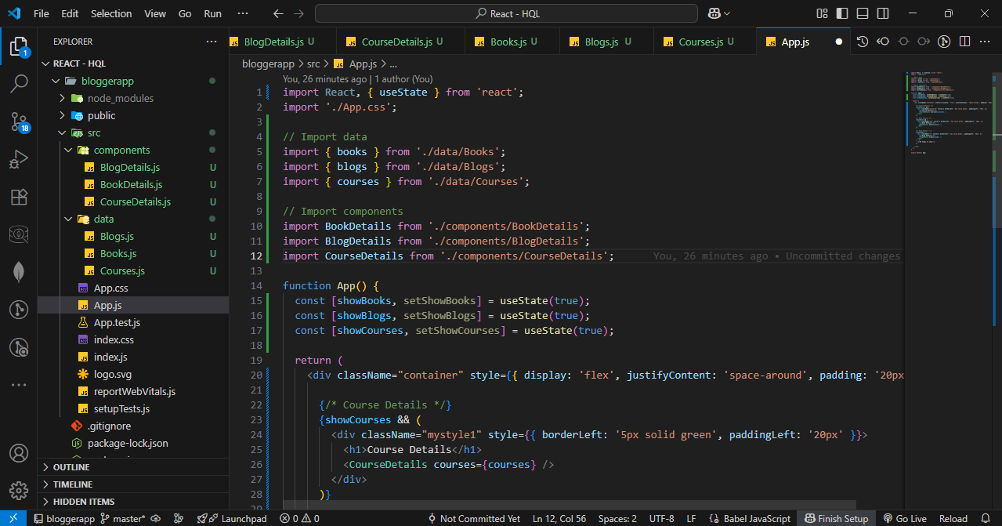
Step – 6 : Style it with app.css.
App.css Code :
.container {
display: flex;
justify-content: center;
align-items: center;
gap: 60px;
height: 100vh;
padding: 20px;
box-sizing: border-box;
}

.section {
border-left: 5px solid green;
padding-left: 20px;
min-width: 220px;
}
.section0 {
min-width: 220px;
font-size: x-large;
}

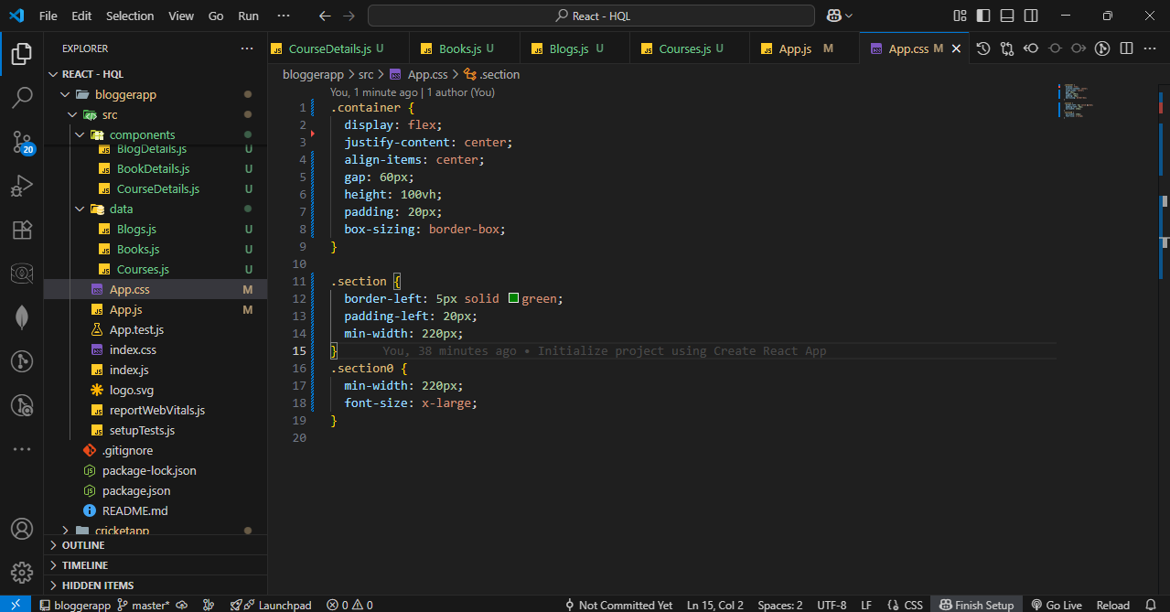

Step – 5 : Start the server.
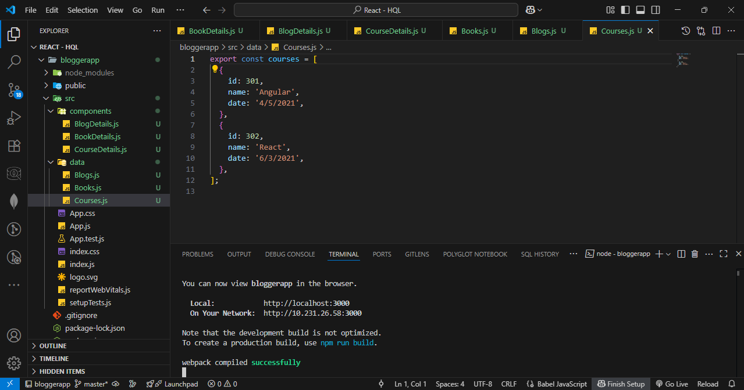

OUTPUT :
